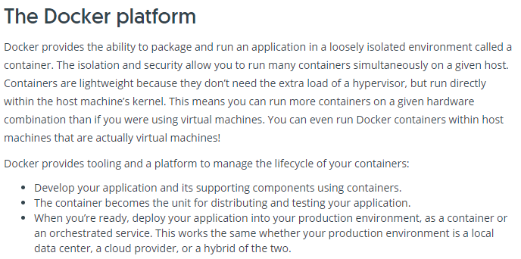

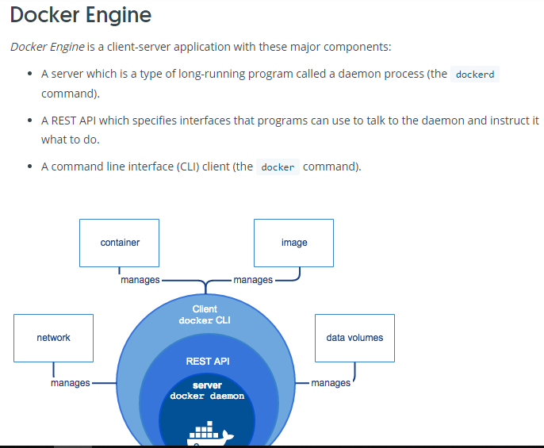

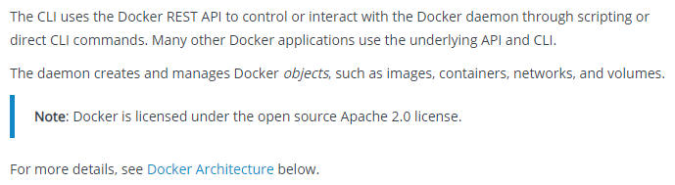

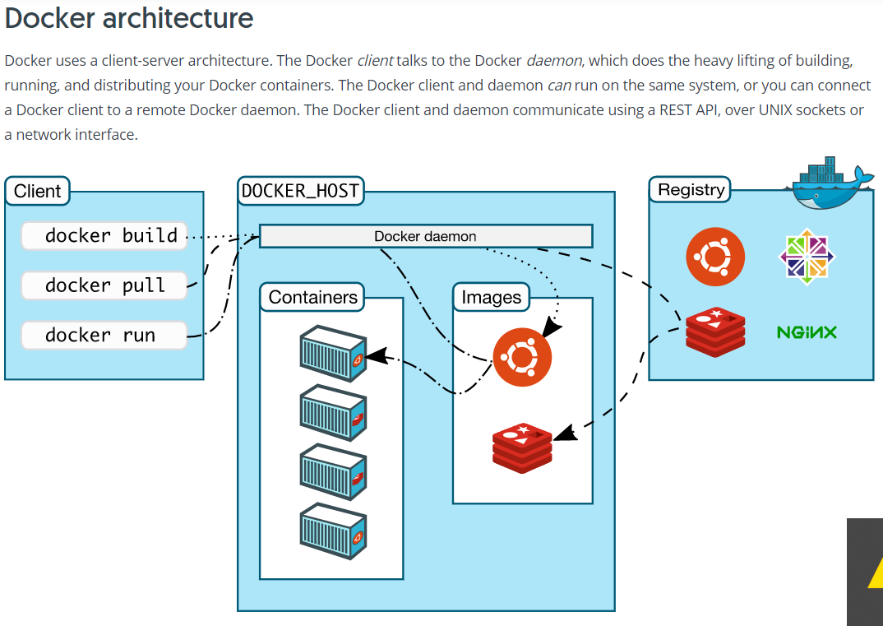

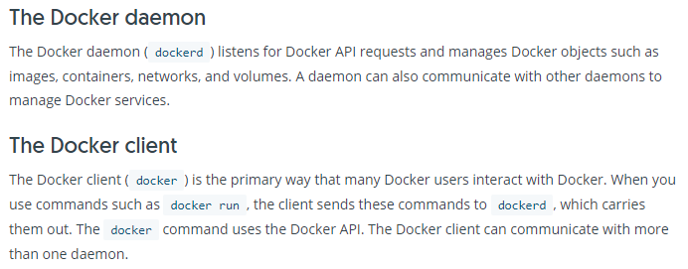

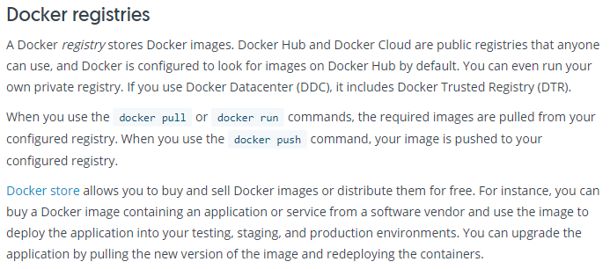

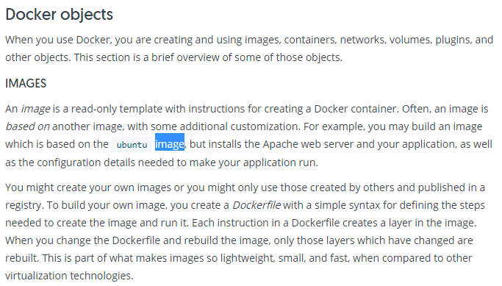

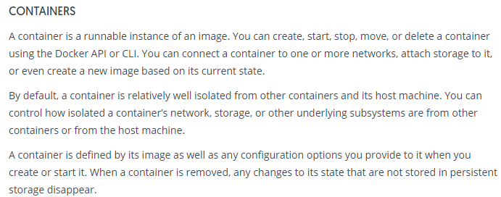

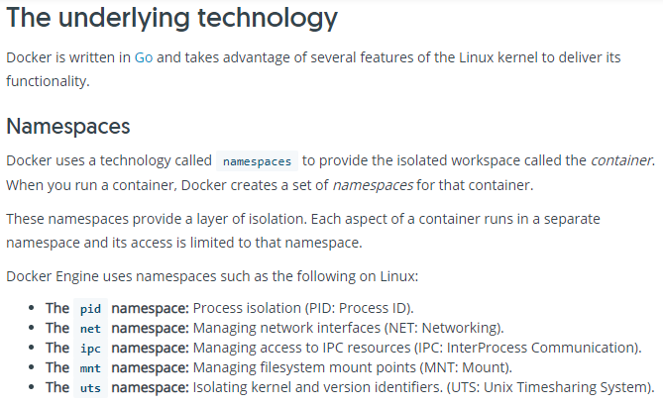

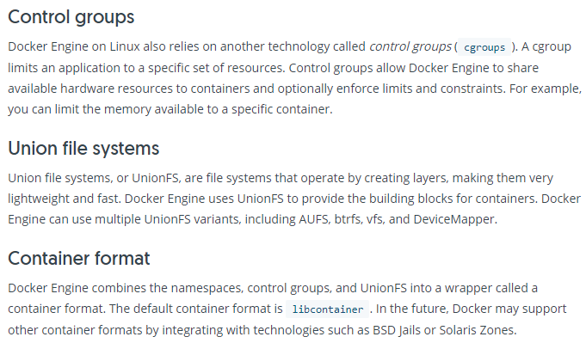

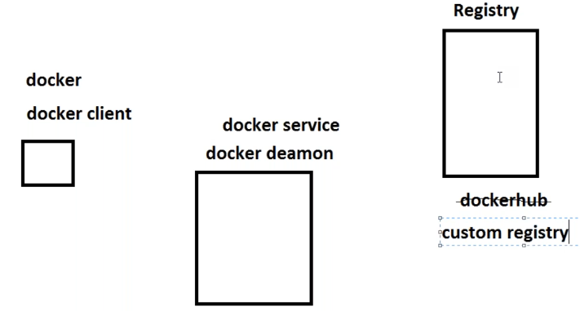

* Docker client is where users interact and run commands
* But it won’t do anything in client, it will run those commands in docker daemon
* Docker daemon is a service which runs on OS
* If it has the image locally, it will give from there, otherwise it will speak to registry
* Using the docker hub which is public might not good for the organisation, so we can have own custom registry which is not shared others
* Registry contains images

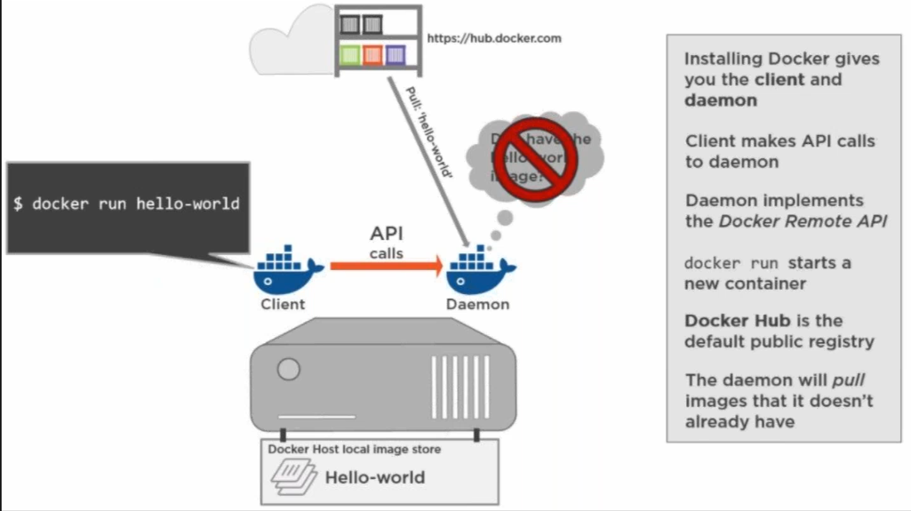

* If we run any image in client, it goes to daemon and checks if the image is there, if not it will go to registry, the default registry is docker hub
* If it is found, it will download but it won’t run, now the daemon will run the image to create the container out of this
* Executed image will be in container, to build the container we need image
* In that container, we will have the application alive